PROCESS TO CREATE AN ACCOUNT TO REGISTER FOR HIB TRAININGS

- Go to www.njpsa.org and click the "Login" button in the upper right hand corner.
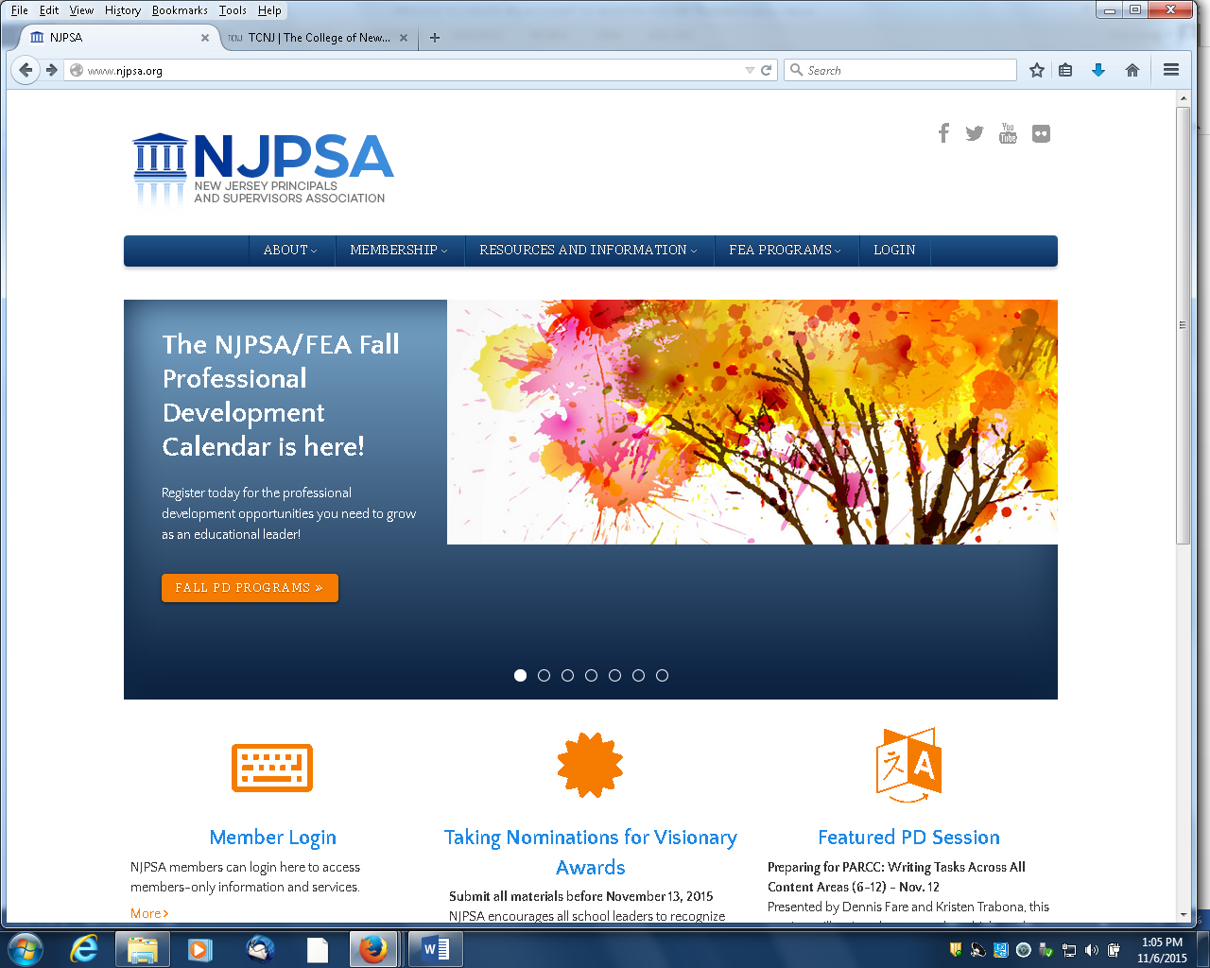

2. Scroll down the page and click the "Create an Account" button on the right side of the page.
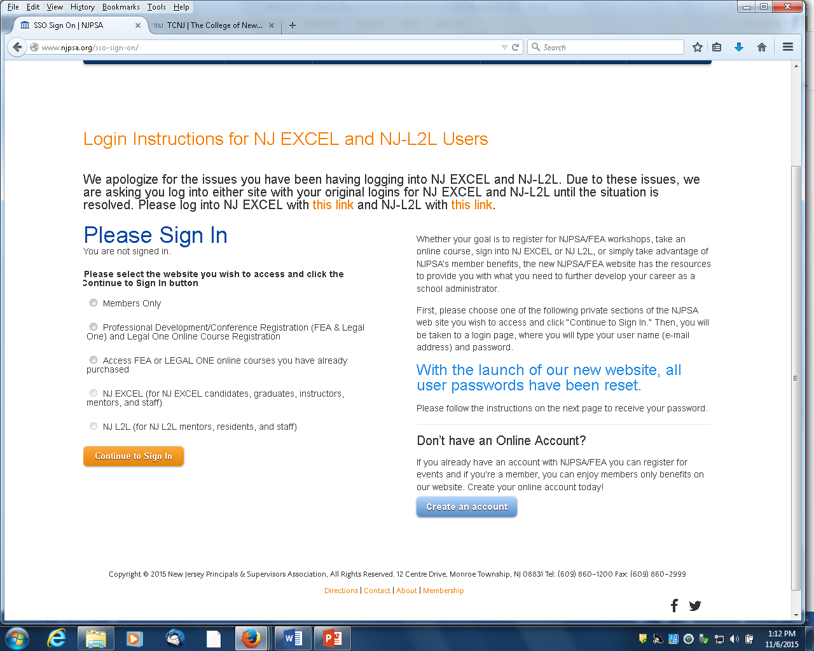
3. Follow the steps to create an account. You will receive an email confirmation with your password that will enable you to log in and purchase courses.

4. If you are unsure whether or not you have an account, please use the “forgot password” buttonon our login page along with your email address to have your password sent to you.

PROCESS TO PURCHASE COURSES
After you have created an account and successfully logged in, please follow these instructions:

1. Go to www.njpsa.org and Click the "Login" button in the upper right hand corner.

2. You will see a page that has various Sign In options. Click "Professional Development Conference Registration (FEA and LEGAL ONE) and LEGAL ONE Online Course Registration." Then click the "C Continue to Sign In" button.
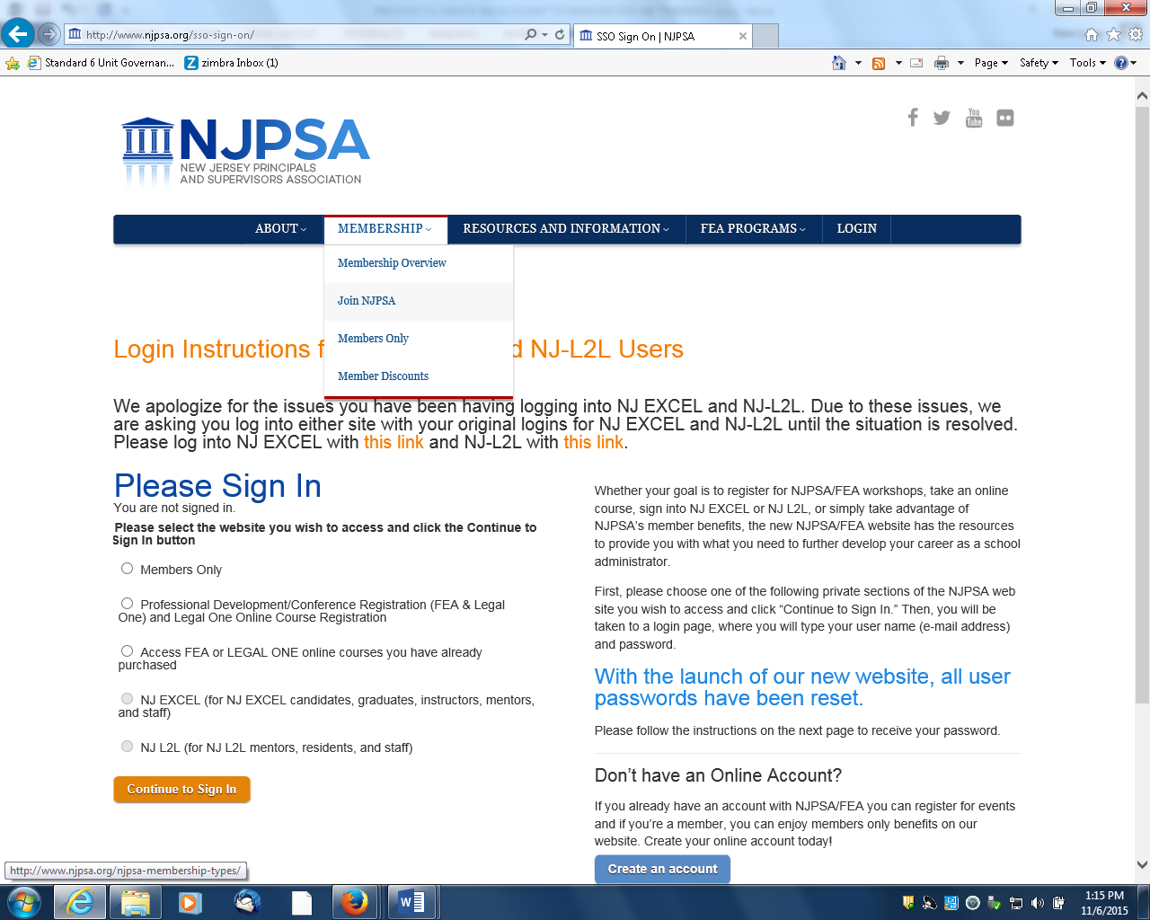

3. Enter your Username and Password and click "Sign In".

4. You will see a Welcome screen with your name. On the right hand side of the screen, click on "View and register for our online courses, including Signs Matter: Suicide Prevention." 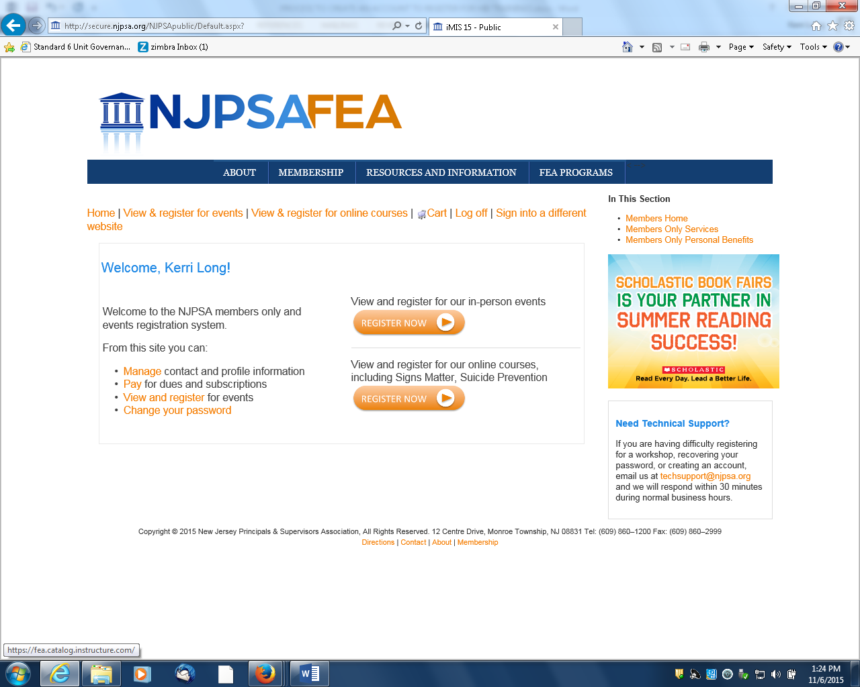

5. Scroll down the page and click on the course entitled "Bullying 101 for Educators".
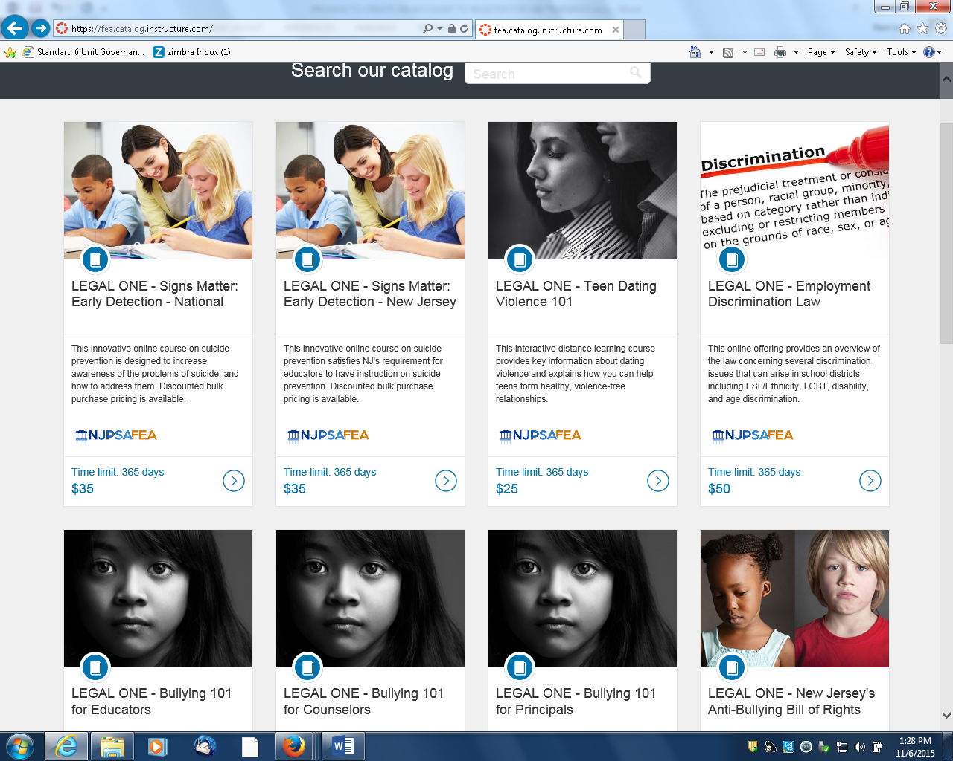

6. You will be taken to a page with a detailed course description. Scroll down the page and click where it says "Click here to register".

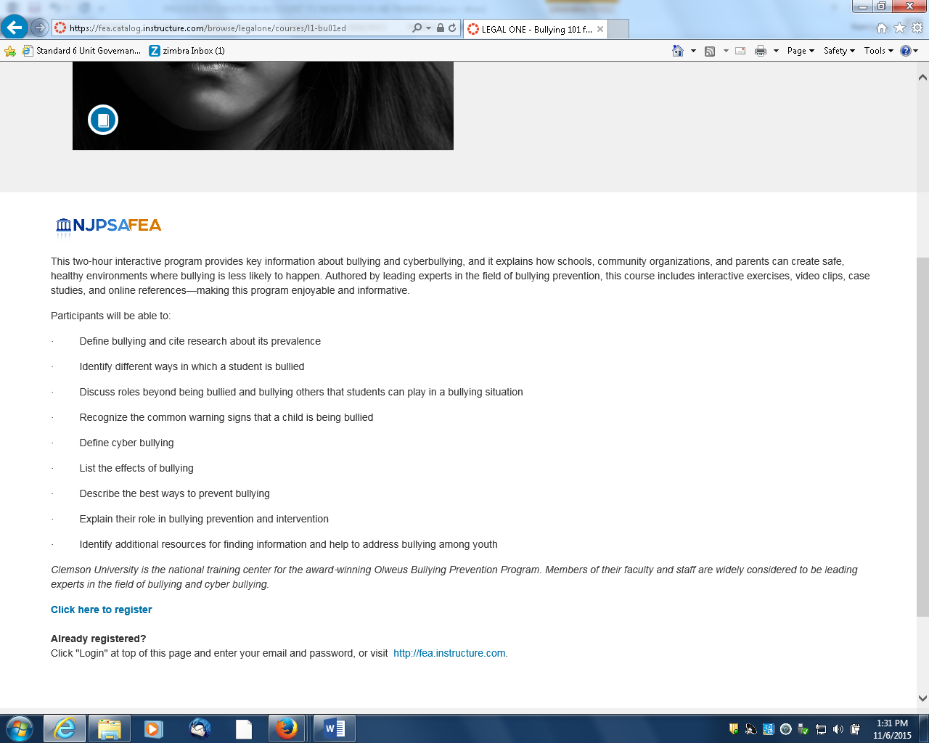

7. You will be taken to a registration page for this course. You will see the price for the registration fee, but that will be discounted later in the process. You will also see a box that asks are you registering yourself for this course. Click "Yes", then click the "Register" button. (NOTE: Do not enter any information in the "Licenses to Purchase" box. That is only used for bulk purchases, NOT for individual purchases.)

8. To add a second online course to your shopping cart, click "View and register for online courses" which is near the top of the screen.

9. Repeat Steps 2-7 for your second course, NJ's Anti-Bullying Bill of Rights.

10. The next step is the shopping cart. Enter "TCNJ1516" into the promotion code box and click "Apply Discount". This will reduce the price of each course by $10 for each course. Then click the "Next" button. You will then be prompted to enter your credit card information for payment. Once you enter this information, click the "Next" button. Finally, on the next page, click the "Submit Order" button and the order will be completed.

11. You will then receive a confirmation that says you are registered for the course. NOTE that it may take up to one full business day from the time or purchase before you have access to the online course.

*During the registration process you may be asked to select from a drop down menu identifying your school district, county and position. There is no option for “student.” Please select “Not available” for the district, “Mercer” for the County, and choose the closest match for “not applicable” for the third drop down menu.

PROCESS TO ACCESS COURSES
NOTE that it may take up to 24 hours from the time of purchase before you have access to the online course.

1. Go to njpsa.com/legalonenj.

2. In the middle of the top of the page, click the link that says "Access and Complete Your Online Courses."

3. This will take you to the Single Sign On page. Click the bubble that says :"Access the FEA or LEGAL ONE online courses you have already purchased."

4. You will be prompted to login and enter your email address and password.

5. You will then be taken to the "Canvas" site where the courses reside. Click on the courses you have registered for and begin.

